# Daily Dish Site Plan

## Charles Bowes

## WDD 130

## Overview

### Purpose

Give people a new recipe every day to try, helping indecisive people to pick a recipe

### Audience

Cooks who can’t pick a recipe to cook

## Branding

### Website Logo



## Style Guide

### Color Palette

| **Primary** | **Secondary** | **Accent 1** | **Accent 2** |
| --- | --- | --- | --- |
| #3F3F37 | #D6D6B1 | #494331 | #878472 |



### Typography

#### Heading Font: Playfair Display

#### Paragraph Font: Lato

### Navigation

Home Other Recipes

**Basic Idea**

**Daily Dish - Project Description**

**The idea behind my website is to help people explore new meals by offering a *random recipe of the day*. Each time you visit the homepage, you'll be given a unique recipe to try. If the random option doesn’t appeal to you, you can browse a categorized list of recipes, including sections like breakfast, lunch, dinner, vegetarian, desserts, and more. This gives users flexibility while still encouraging culinary creativity.**

**The website will include:**

* **A daily random recipe**
* **Recipe categories and filters**
* **Ingredients and step-by-step instructions**
* **Cooking time and difficulty level**
* **User ratings and favorites**
* **A search bar for specific dishes**

**What makes this site unique is its *daily surprise element*, which encourages users to try meals outside of their comfort zone. The clean layout, easy navigation, and constantly updating content create a fresh, fun experience for home cooks of all skill levels.**

**Content**

[put all content for the pages here, including written text and images]

**Wireframes**

### Home

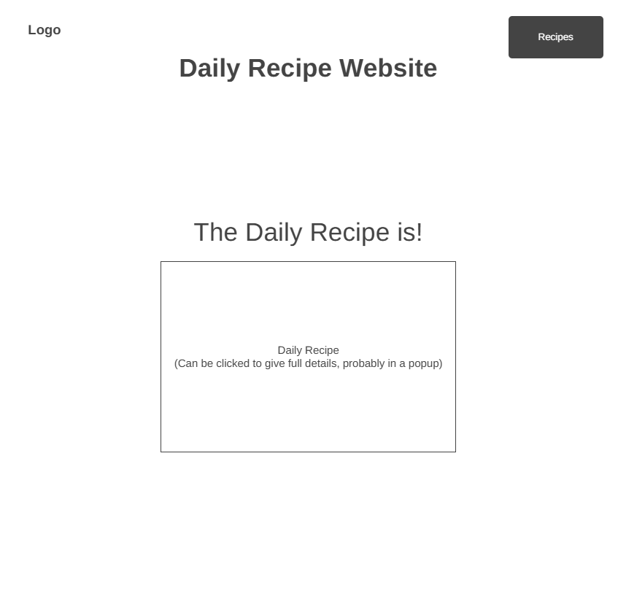

**Recipes**

